**LAB ASSIGNMENT-2.4**

Task Description#1:

Open Google Colab and use Gemini to generate python code that performs sorting of a list using both bubble sort and Python’s built in sort function Compare the two implementations.

Prompt 1:

Create a Python Function which implements Bubble sort algorithm in a list.

Code & Output:

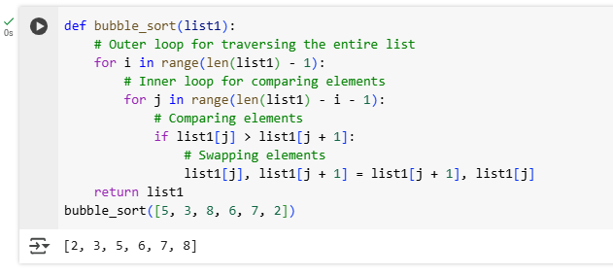

Prompt 2:

Create a python function for sorting a list using built-in- function sort()

Code & Output:

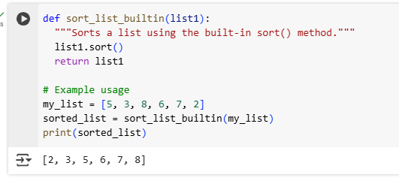

Task Description #2:

In Colab use Gemini to generate a python function that takes a string and returns ;The number of vowels,the number of consonants,the number of digits in the string

Expected Output # 2:

Complete the function that iterates through characters of a string and counts vowels consonants and digits

Prompt 1:

write a python function that takes a string and returns The number of vowels, consonants ,the number of digits in the string with example.

Code:

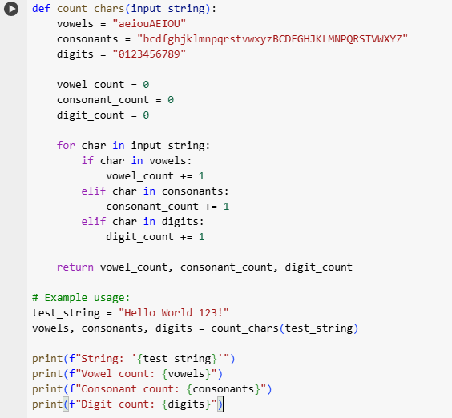

Output:

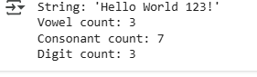

Task Description #3:

Use Gemini to generate a Python program that performs file handling.

Create a text file

Write sample text

Read and display the content

Expected Output:

Functional code that create a .txt file,writes content to it and reads it back

Prompt :

create a python program which performs file handling create a .txt file write text to it and read it back.

Code:

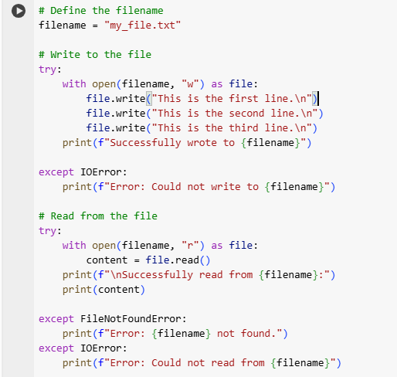

Ouput:

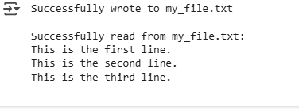

Task Description #4:

Ask Gemini to generate a Python program that implements a simple calculator using functions(add,subtract,multiply,divide)Then asks Gemini to explain how code works.

Expected Output # 4:

Complete calculator code with user input and operation selection

Line-by-line explanation or markdown-style explanation by Gemini

Screenshot of both the code and explanation in Colab

Prompt:

create a python code for a simple calculator using functions(add,sub,mul,division) with user input of number and selction of operations.

Code:

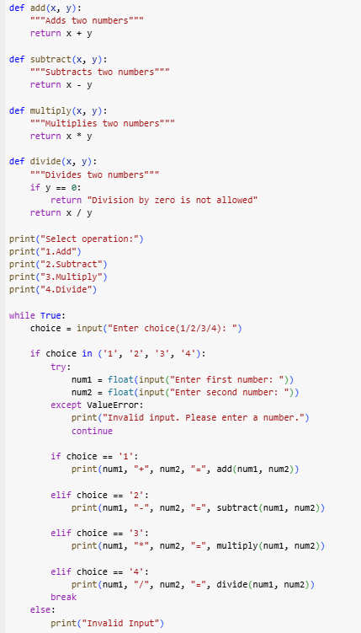

Output:

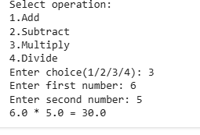

Explanation:

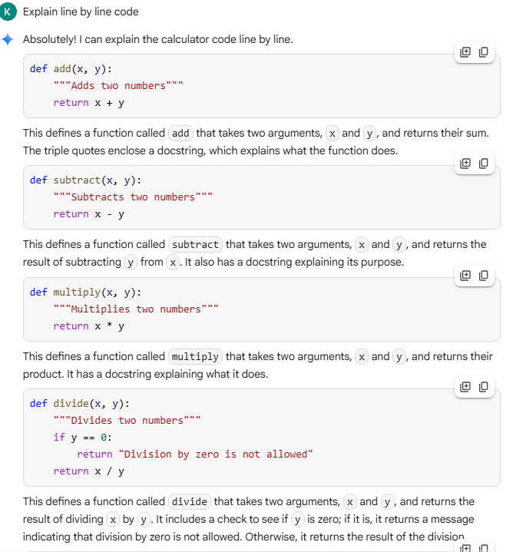

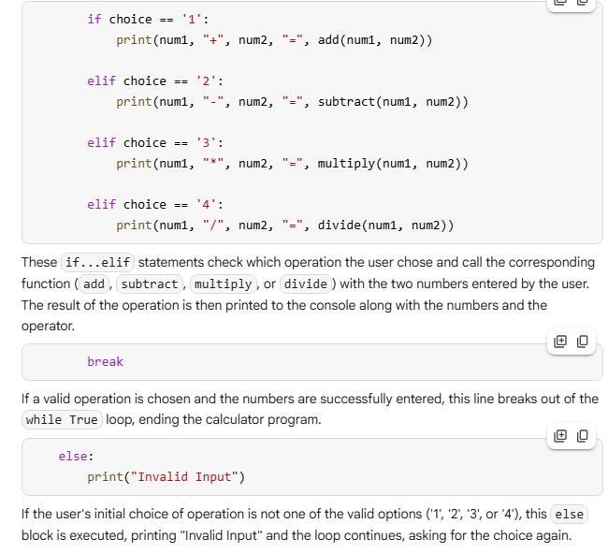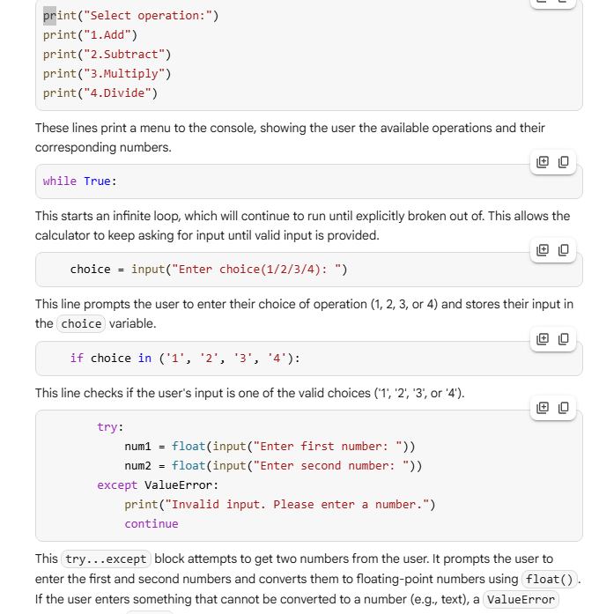

Task Description #5:

Use Gemini to create a Python program that checks if a given year is a leap year or not Try different prompts styles and see how Gemini modifies the code suggestions.

Output:

A functional program to check a leap year with a sample input/output

Atleast two versions of code

A short comparision of which version is better and why

Prompt:

create a python program for checking a given year is leap year or not.

Code:

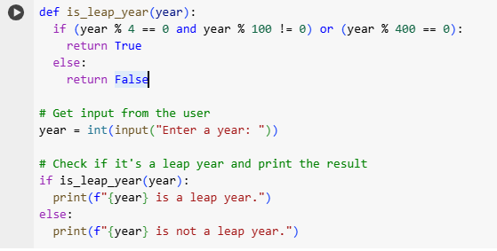

Output:

